SQLite 10

GUI and SQLite



LILLEBAELT ACADEMY OF
PROFESSIONAL HIGHER EDUCATION

Author
Martin Grønholdt
mart80c7@edu.eal.dk

Sunday 30 April 2017

Table of Contents
Introduction 1
Functional description 1
User interface 2
1. Name and Address 3
Conclusion 7

Introduction
This document introduces the development aspects of a customer database using SQLite as the data storage and Flask to present an interface for the user.

This is a bare bones implementation that would benefit from further development in these areas:
- Replace/Delete customers.
- Easier deployment (Docker, venv, k8s, …).
- Proper validation of form input.
- Proper validation of SQL queries.
- Search in the customer data.
- Encrypt traffic.
- REST API.

All hand ins for this course is available on GitHub at:
https://github.com/deadbok/eal_programming

Functional description
The program is a basic customer database, showing a list of all customers and add new ones, as seen in the use case diagram below.
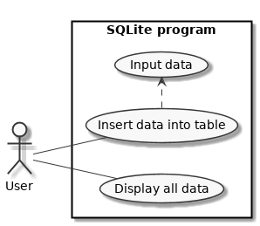
Use case diagram
The graphical user interface has been implemented using Flask, which is a micro web framework for Python. The program act like a web server, and the user interface is accessed using a regular HTML5 compliant browser.
Using a web framework has both advantages and disadvantages in comparison with the a standard OS managed GUI components.

Advantages
- Default client/server architecture
  - No installation on the users computer, only a web browser is needed.
  - Centrally stored database.
  - Easier deployment due to single installation.
- Familiar interface using the Bootstrap CSS framework.
- User interface is build using HTML which is more accesible than a regular GUI toolkit.
- Simple to add a REST api.
Disadvantages
- Network based
  - Unencrypted traffic (use encryption).
  - Higher exposure.
- Installation is harder for non-technical users
- Ideally needs a Unix server to run.

Running
To run the program in development mode, run “run.py” the root directory of the project directory.
* Running on http://0.0.0.0:5000/ (Press CTRL+C to quit)
* Restarting with stat
* Debugger is active!
* Debugger pin code: 147-873-485
127.0.0.1 - - [30/Apr/2017 22:12:07] "GET /add HTTP/1.1" 200 -
127.0.0.1 - - [30/Apr/2017 22:16:10] "GET /favicon.ico HTTP/1.1" 404 -
127.0.0.1 - - [30/Apr/2017 22:26:40] "POST /add HTTP/1.1" 302 -
127.0.0.1 - - [30/Apr/2017 22:26:41] "GET / HTTP/1.1" 200 -
127.0.0.1 - - [30/Apr/2017 22:27:08] "GET /add HTTP/1.1" 200 -
127.0.0.1 - - [30/Apr/2017 22:33:11] "POST /add HTTP/1.1" 302 -
127.0.0.1 - - [30/Apr/2017 22:33:11] "GET / HTTP/1.1" 200 -
127.0.0.1 - - [30/Apr/2017 22:33:18] "GET /add HTTP/1.1" 200 -
127.0.0.1 - - [30/Apr/2017 22:34:34] "POST /add HTTP/1.1" 302 -
127.0.0.1 - - [30/Apr/2017 22:34:34] "GET / HTTP/1.1" 200 -
* Detected change in '/mnt/data/Documents/Skole/It-et/2016/programming/SQLite 10/app/views/add.py', reloading
* Restarting with stat
* Debugger is active!
* Debugger pin code: 147-873-485
Console output of the program running in development mode.
The console output shows request and responses handled by the app. Notice that because the program runs in development mode, it will reload when it detects a change in one of the source files.

User interface
The user interface is made using HTML and the Python template language Jinja 2. The GUI mock-ups are written in HTML and the data logic is achieved using Jinja 2. The user interface is accessed in a browser using the URL that points to the installed version, in case of the development version, this URL is http://localhost:5000/.
The main window shows the current customer records and a button to add a new customer record. The customer id is automaticity incremented by SQLite when a new customer is added.
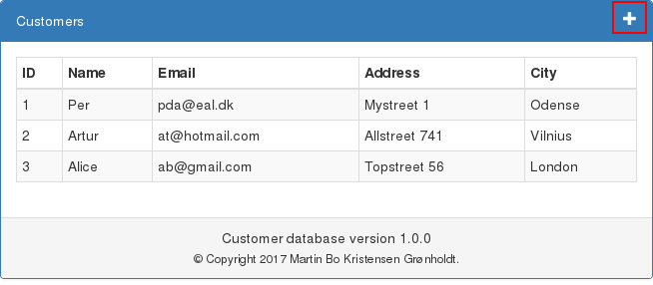
Main view with customer data and the framed add button in the upper right corner.
The interface to add a customer is a regular HTML form that submits a POST request back to the program.
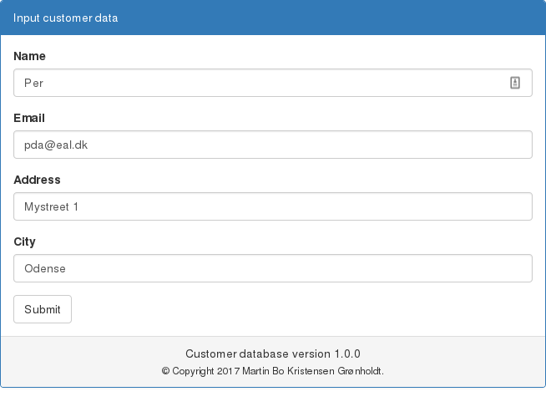
User interface for adding a new customer.
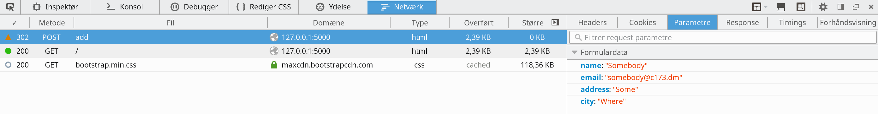
The POST request for a new customer caught in Firefox.

Source:
#!/usr/bin/env python3
# -*- coding: utf-8 -*-
# The above lines tell the shell to use python as interpreter when the
# script is called directly, and that this file uses utf-8 encoding,
# because of the country specific letter in my surname.
"""
Name: Program 5 "RetailItem Class"
Author: Martin Bo Kristensen Grønholdt.
Version: 1.0 (2017-02-19)

Program for entering details in to a ProductionWorker class.
"""
import tkinter
from tkinter import StringVar

class MyGUI:
def __init__(self, parent):
"""
Constructor.
Creates the UI components and layout.

:param parent: The parant widget.
"""
# Create the main window widget.
self.parent = parent

# Create a StringVar used to modify the label text.
self.info_str = StringVar()

# Create a Label widget
self.info_label = tkinter.Label(self.parent,
textvariable=self.info_str,
height=3)
# Place the label at the top of the grid layout
self.info_label.grid(row=0, column=0, columnspan=3, padx=2, pady=2)

# Create the buttons.
self.info_button = tkinter.Button(self.parent,
text='Show info',
command=self.add_data)
self.quit_button = tkinter.Button(self.parent,
text='Quit',
command=self.parent.destroy)

# Add the buttons to the second row of the layout grid.
self.info_button.grid(row=1, column=0, padx=5, pady=5)
self.quit_button.grid(row=1, column=2, padx=5, pady=5)

def add_data(self):
"""
Event handler to add data to the label when the info button is pressed.
"""
self.info_str.set('Steven Marcus\n' +
'274 Baily Drive\n' +
'Waynesville, NC 27999')

def main():
"""
Main function, instantiates TK and the GUI class.
"""
root = tkinter.Tk()
# Create an instance of the MyGUI class.
my_gui = MyGUI(root)
# Enter the tkinter main loop
tkinter.mainloop()

# Run this when invoked directly
if __name__ == '__main__':
main()

prog1_qt5.py

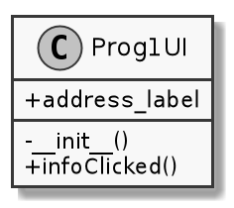
UML graphic representation diagram of the QT5 version

Source:
#!/usr/bin/env python3
# -*- coding: utf-8 -*-
# The above lines tell the shell to use python as interpreter when the
# script is called directly, and that this file uses utf-8 encoding,
# because of the country specific letter in my surname.
"""
Name: Program 5 "RetailItem Class"
Author: Martin Bo Kristensen Grønholdt.
Version: 1.0 (2017-02-19)

Program for entering details in to a ProductionWorker class.
"""

import sys

from PyQt5.QtWidgets import QWidget, QPushButton, QGridLayout, QApplication, \
QLabel

class Prog1UI(QWidget):
"""
Class that creates a simple dialog window.
"""

def __init__(self):
"""
Constructor, creates the UI.
"""
# Call the parant constructor.
super().__init__()

# Create the label, using a member variable to be able to reference it
# later.
self.address_label = QLabel('\n\n')

# Create the buttons
info_button = QPushButton("Show info")
quit_button = QPushButton("Quit")

# Create a grid layout
grid = QGridLayout()
grid.setSpacing(10)

# Place the address labe in the top row of the grid and make it span 5
# columns.
grid.addWidget(self.address_label, 0, 0, 1, 5)

# Place the buttons at the second row, with some cells between them for
# spacing.
grid.addWidget(info_button, 1, 1)
grid.addWidget(quit_button, 1, 3)

# Connect event handler for button clicks
info_button.clicked.connect(self.infoClicked)
# Close the window on clicking "Quit"
quit_button.clicked.connect(self.close)

# Set the layout of this widget
self.setLayout(grid)

# Set title
self.setWindowTitle('Program 1 QT5 GUI')
# Show window
self.show()

def infoClicked(self):
"""
Handler that is called when the info button is clicked
"""
# Set the text of the label
self.address_label.setText('Steven Marcus\n' +
'274 Baily Drive\n' +
'Waynesville, NC 27999')

def main():
"""
Main program
"""
# Instantiate the QT application class
app = QApplication(sys.argv)
# Create out window
ui = Prog1UI()
# Exit when done.
sys.exit(app.exec_())

# Run this when invoked directly
if __name__ == '__main__':
main()

Result
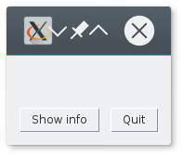  Tk UI before the info button is pressed | 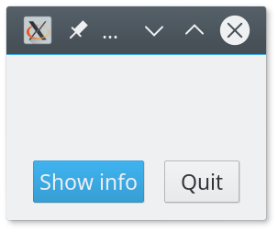  QT5 UI before the info button is pressed
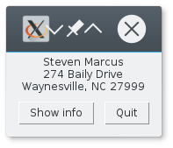  Tk UI after the info button is pressed | 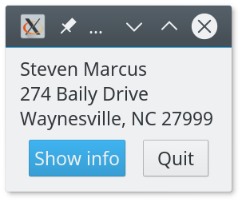  QT5 UI before the info button is pressed

Notice the title bar, the Tk version does not handle the HiDPI resolution of 3200x1200 that well. It may be possible to tweak this, but QT5 handles this out of the box.

Conclusion
GUI programming in Python is fairly simple and understandable, there are a lot of paradigms that are directly portable from other GUI libraries and languages.

